ID:N210264
NAME:Alapati.Sree Harsha
ROLL-NO:22
LAB-02
Half Adder, Full Adder, Half Subtractor, Full Subtractor
Half Adder
Description:
Half Adder performs the corresponding addition operation based on its(2) inputs.
Circuit
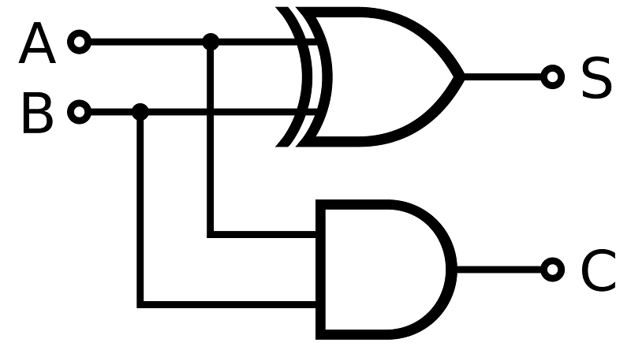

Truth Table
A | B | Sum | Carry
0 | 0 | 0 | 0
0 | 1 | 1 | 0
1 | 0 | 1 | 0
1 | 1 | 0 | 1
Components Required
Multisim, Probes, Interactive Digital Constant, Logic ICs(7408, 7486)
Multisim circuit:
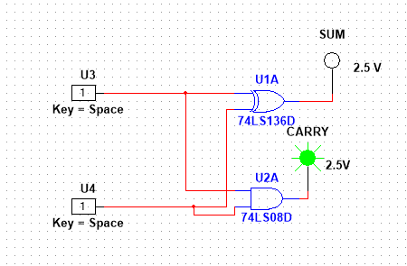

Procedure
- - Connect the components on the Multisim as per the circuit diagram.
- - Power the circuit and verify the functionality of the circuit using the truth table.
Full Adder
Description:
The Full Adder performs the corresponding addition operation based on its(3) inputs.
Circuit
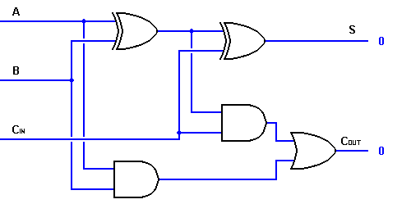

Truth Table
A | B | Cin | Sum | Carry
0 | 0 | 0 | 0 | 0
0 | 0 | 1 | 1 | 0
0 | 1 | 0 | 1 | 0
0 | 1 | 1 | 0 | 1
1 | 0 | 0 | 1 | 0
1 | 0 | 1 | 0 | 1
1 | 1 | 0 | 0 | 1
1 | 1 | 1 | 1 | 1
Components Required
Multisim, Probes, Interactive Digital Constant, Logic ICs(7486 - 2, 7408 - 2, 7432 - 1), Power Supply
Multisim circuit:
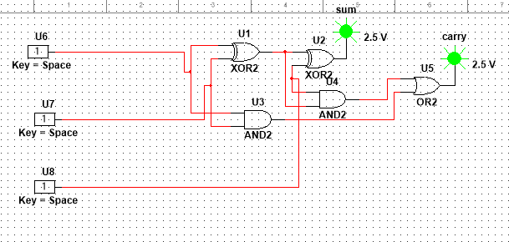

Procedure
- - Connect the components on the Multisim as per the circuit diagram.
- - Power the circuit and verify the functionality of the circuit using the truth table.
Half Subtractor
Description:
The Half Subtractor performs the corresponding subtraction operation based on its(2) inputs.
Circuit
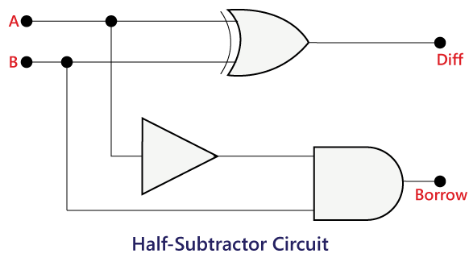

Truth Table
A | B | Difference | Borrow
0 | 0 | 0 | 0
0 | 1 | 1 | 1
1 | 0 | 1 | 0
1 | 1 | 0 | 0
Components Required
Multisim, Probes, Interactive Digital Constant, Logic ICs(7486 , 7408 , 7404), Power Supply
Multisim circuit:
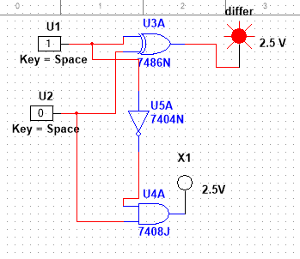
Procedure
- - Connect the components on the Multisim as per the circuit diagram.
- - Power the circuit and verify the functionality of the circuit using the truth table.

Full Subtractor
Description:
The Full Subtractor performs the corresponding subtraction operation based on its(3) inputs.
Circuit

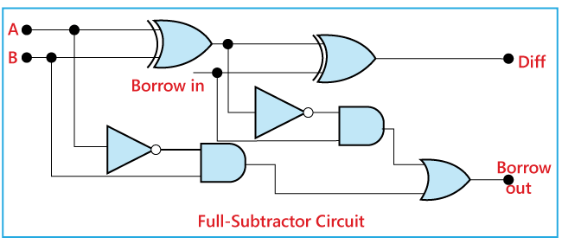

Truth Table
A | B | Bin | Difference | Borrow
0 | 0 | 0 | 0 | 0
0 | 0 | 1 | 1 | 1
0 | 1 | 0 | 1 | 1
0 | 1 | 1 | 0 | 1
1 | 0 | 0 | 1 | 0
1 | 0 | 1 | 0 | 0
1 | 1 | 0 | 0 | 0
1 | 1 | 1 | 1 | 1
Components Required
Multisim, Probes, Interactive Digital Constant, Logic ICs (7486 -2, 7408 -2, 7404 -2, 7432 -1), Power Supply
Multisim circuit:

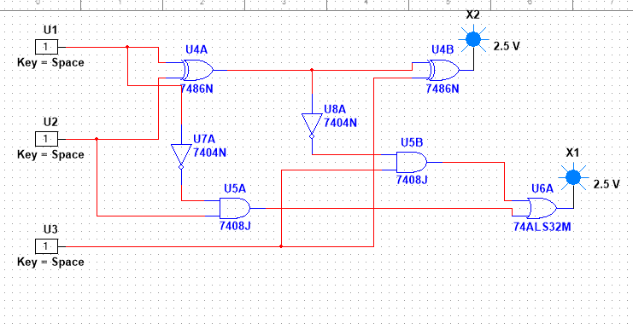

Procedure
- Connect the components on the Multisim as per the circuit diagram.
- Power the circuit and verify the functionality of the circuit using the truth table.

